STEM Catapult Challenge
Your job is to build a catapult with supplies you can find around the house. You may use anything to build your catapult. (You have two weeks to complete this project. Take your time, plan and do your best.
You can also use anything you want for a projectile (the item that you are launching)
- Watch the following video about catapults. Remember, you will need your district username and password to get into the video (it is the same username and password you use for FreshGrade and Teams)
https://app.discoveryeducation.ca/learn/videos/97685edf-ea6f-45a5-afb1-6f3e079a4fe0/

Here are a couple examples of catapults. You can do some more research online to get some other ideas.
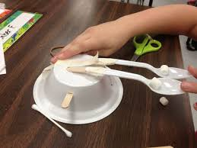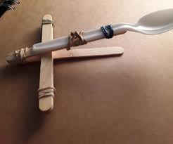

- Fill out the following brainstorming form. If you do not have a printer, just write it down on a piece of paper.
Plan your catapult and what supplies you will need before you start building.
- Try out your catapult and record your results. You will be testing three different aspects of your catapult.
- Accuracy – how close can you get to your target. Try at least 10 times and record how many tries hit the target
- Power – how far can you launch your object? Measure how far your object travels. You can use a measuring tape for this.
- Tower – build a tower from blocks, plastic cups or anything you have around the house that won’t break. See how many tries it takes you to knock down the tower.

STEM CATAPULT CHALLENGE

Imagine: Brainstorm several ideas you have for how to use the above materials in your catapult. Draw pictures!

Design: Draw out your best catapult design. Be sure to label where you will use all of the different materials (Popsicle sticks, tape, plastic spoon, etc.).

Test: How well did your catapult work? What are two ways you can change your catapult to make it better? List these ideas here, and then start over at the beginning of this sheet.

Accuracy:
Trial | Did you hit the target? | What do you need to change to be more accurate?
1
2
3
4
5
6
7
8
9
10

Power:
Trial | How far did your projectile go? | What do you need to change to be more accurate?
1
2
3
4
5
6
7
8
9
10

Tower:
Trial | How many tries did it take to knock the tower down? | What was your tower made from and what did you use as a projectile?
1
2
3
4
5
6
7
8
9
10

